**End of Line (EOL) Test for MOTOR Procedure**

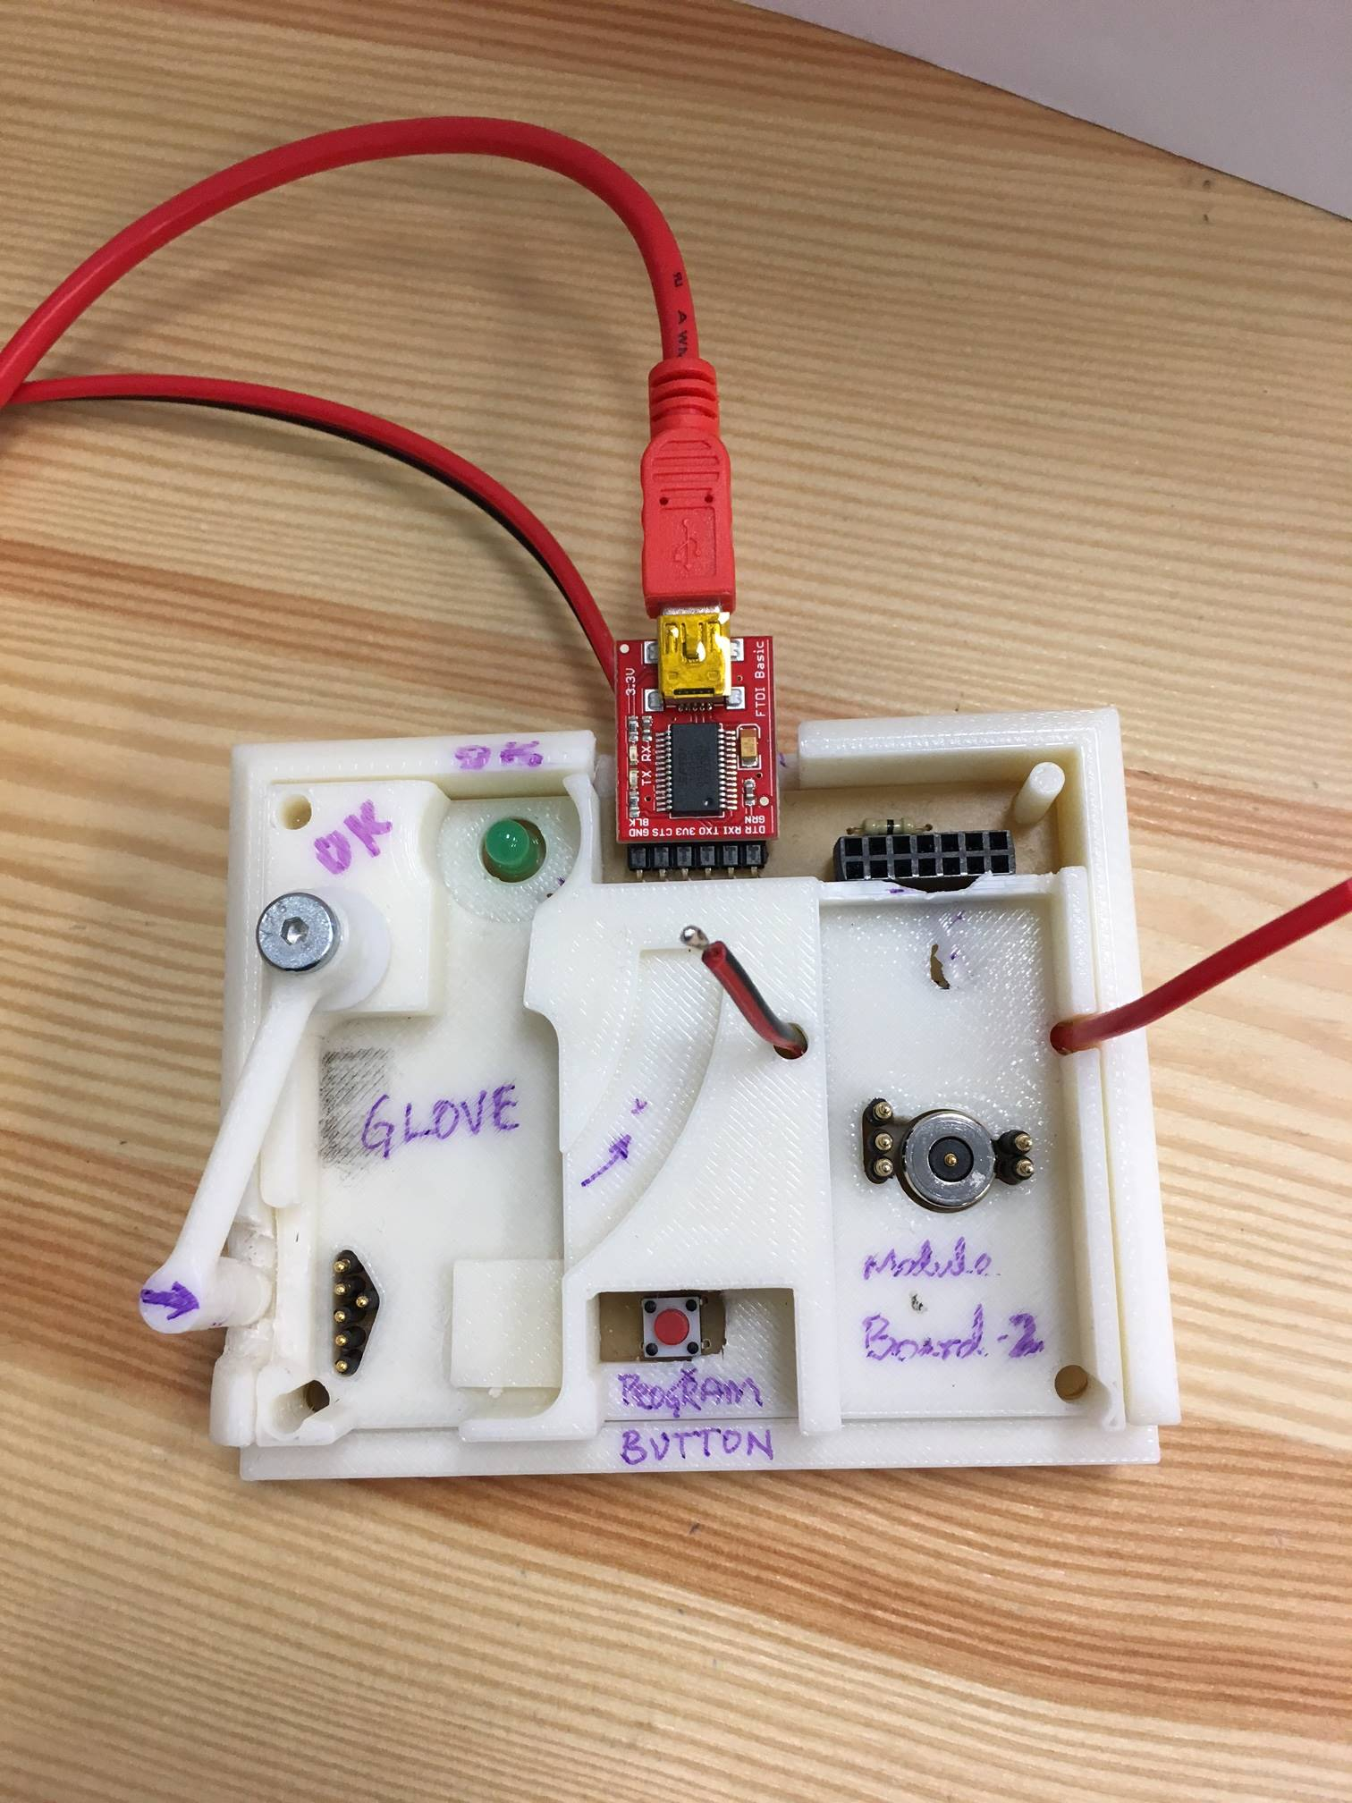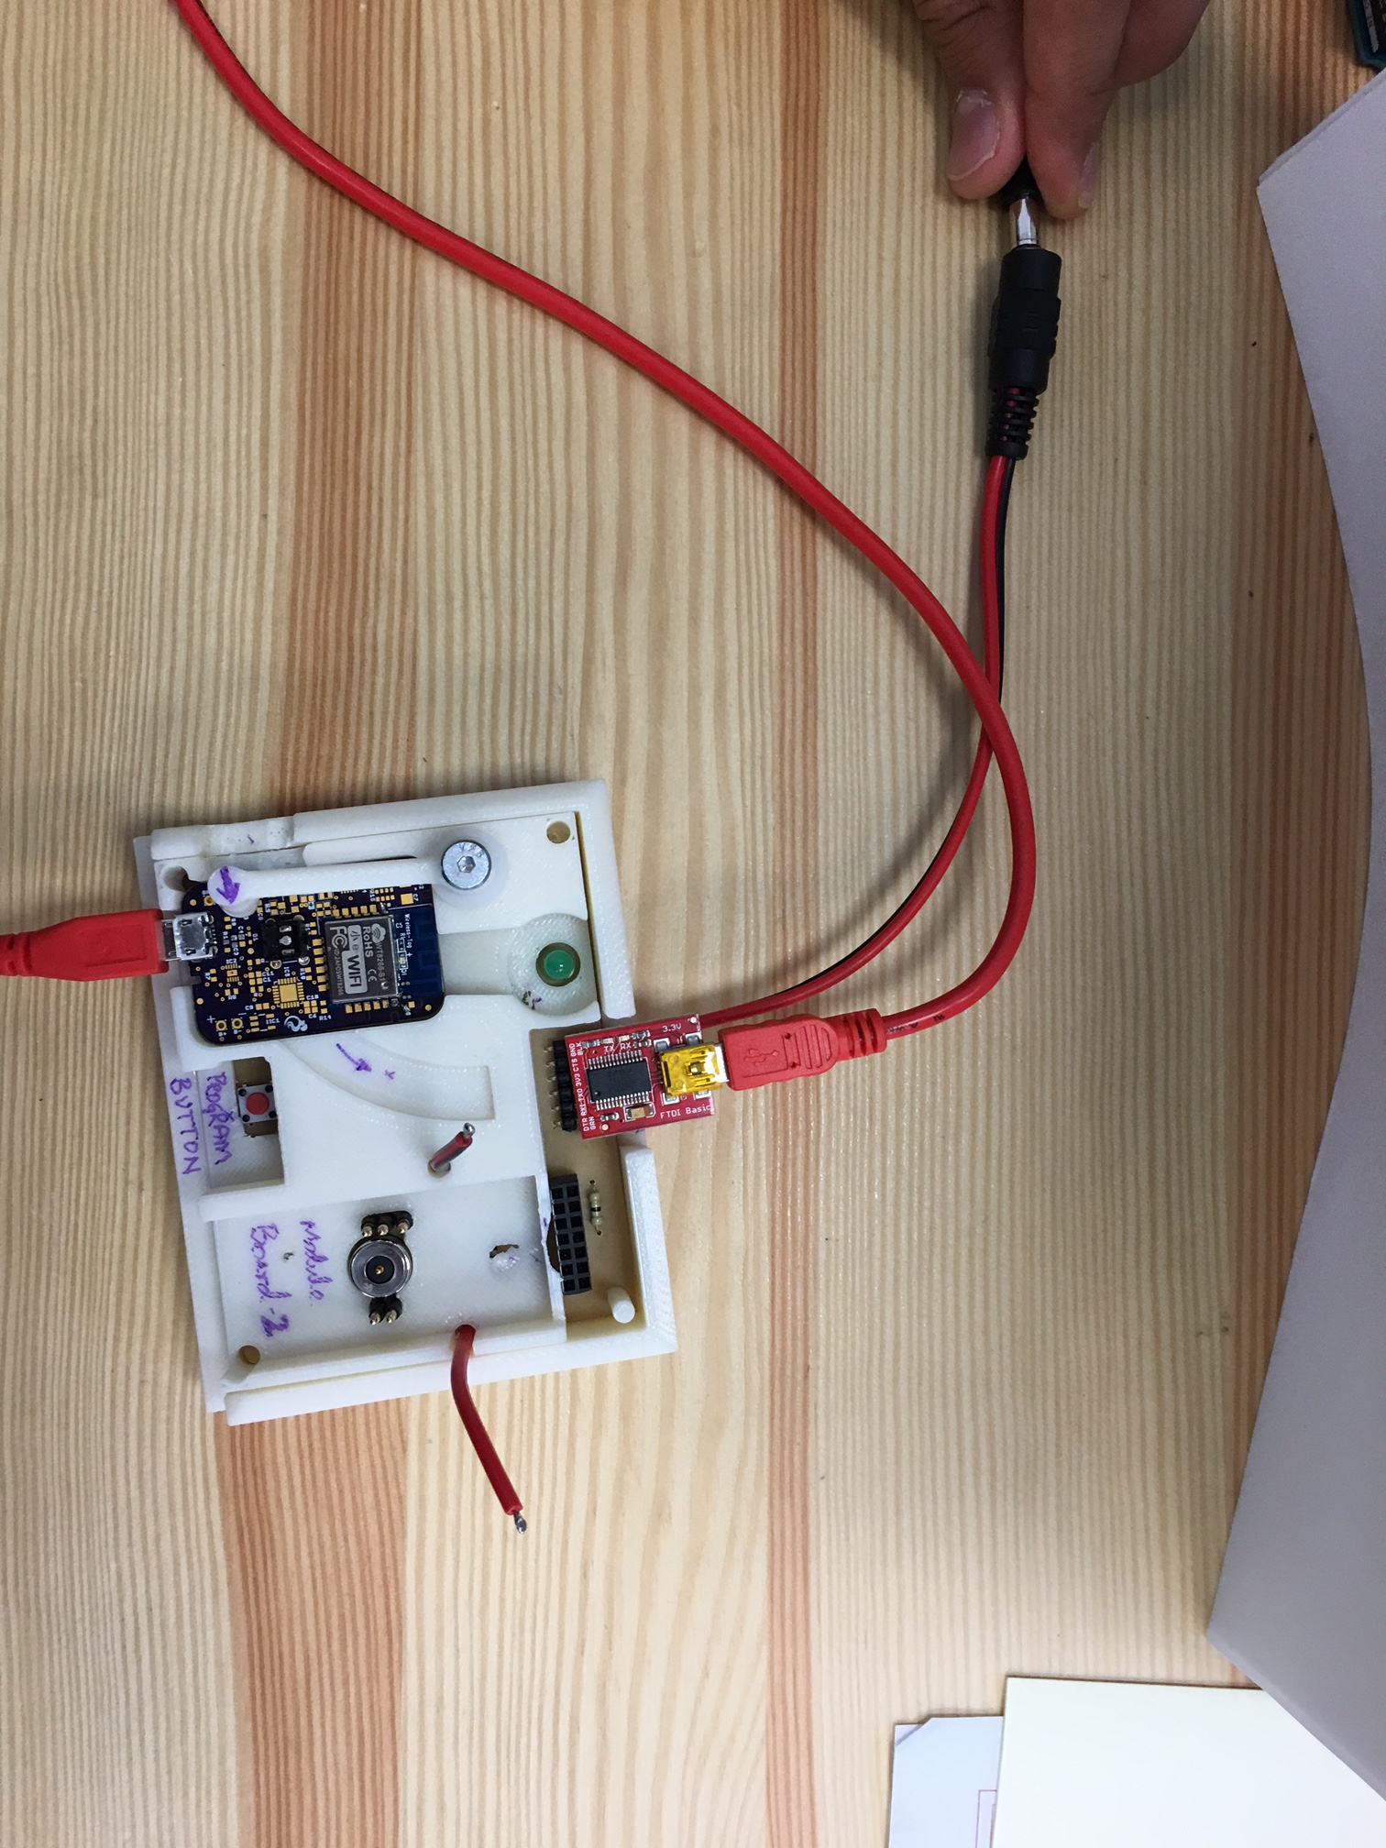

**Setup of Programmer (DO ONLY ONCE):**

1

**3. Double CLICK DeviceMgr.bat**

**1. Unzip 2.OPEN**



**4. DOUBLE CLICK RunThis.bat**

**5. ENTER ONLY  
 NUMBER**

**6. Press Enter**

**SUCCESS**

**Programmer Ready**

**Insert 9V DC**

**Insert USB Cable**

1. **Insert USB Cable into Computer**
2. **Insert USB-B Type into FTDI**
3. **Insert 9V DC Adapter**

**Setup of Installer (Do ONLY ONCE):** 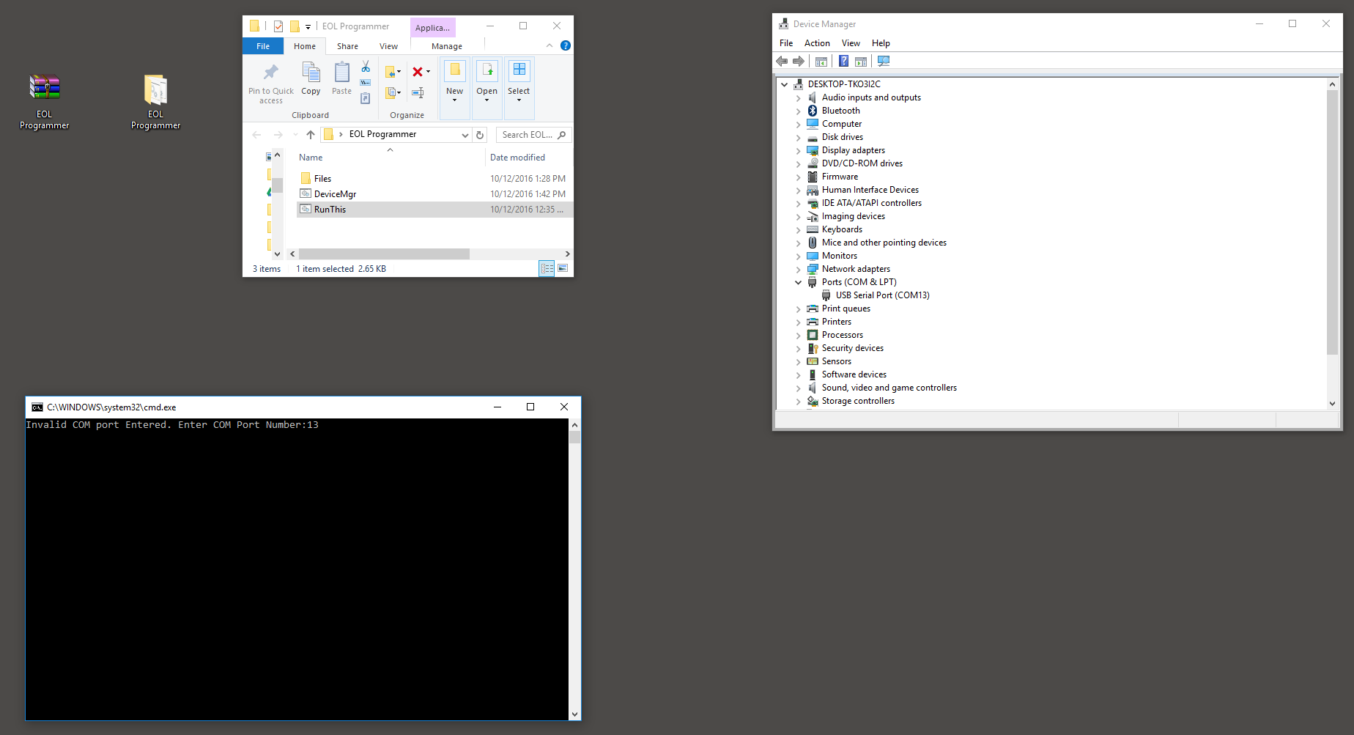

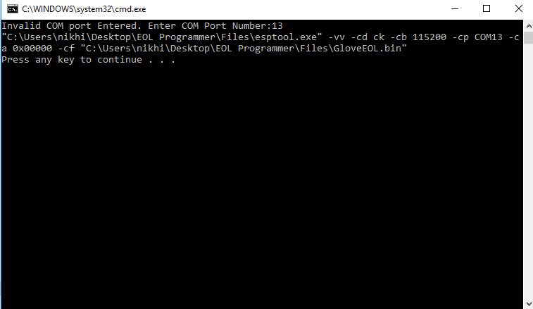

**DO NOT CLOSE THIS WINDOW**



**Setup of Installer (Once More):**

1. **Unzip and Extract the compressed folder for the Glove:**
2. **Open the Folder**
3. **Double-Click the DeviceMgr.bat and find the Ports (COM & LPT)**
4. **Double-Click RunThis.bat**
5. **Enter Number from Step 3.**
6. **Press Enter.**

**PROGRAMMING STEPS:**

Step # 1: Insert Module PCB into Programmer as shown

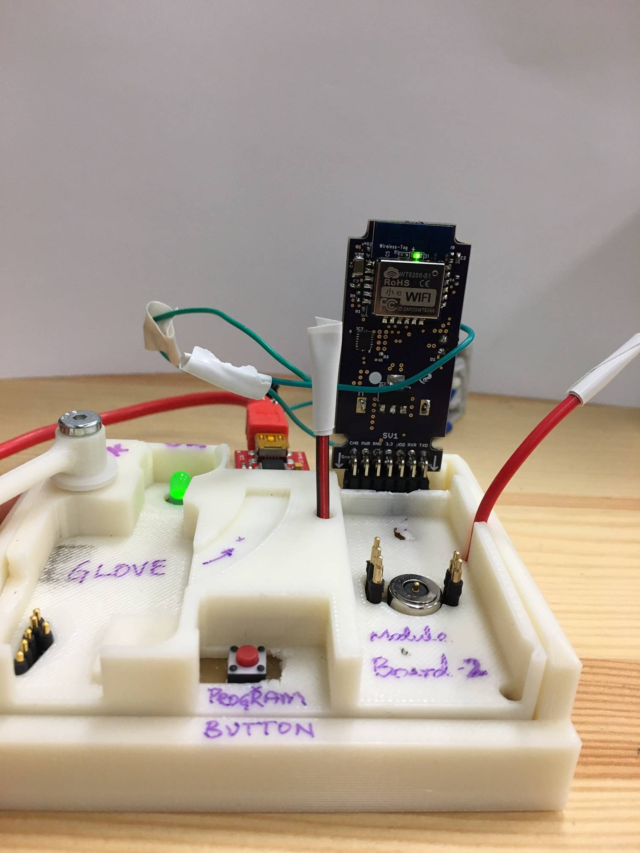

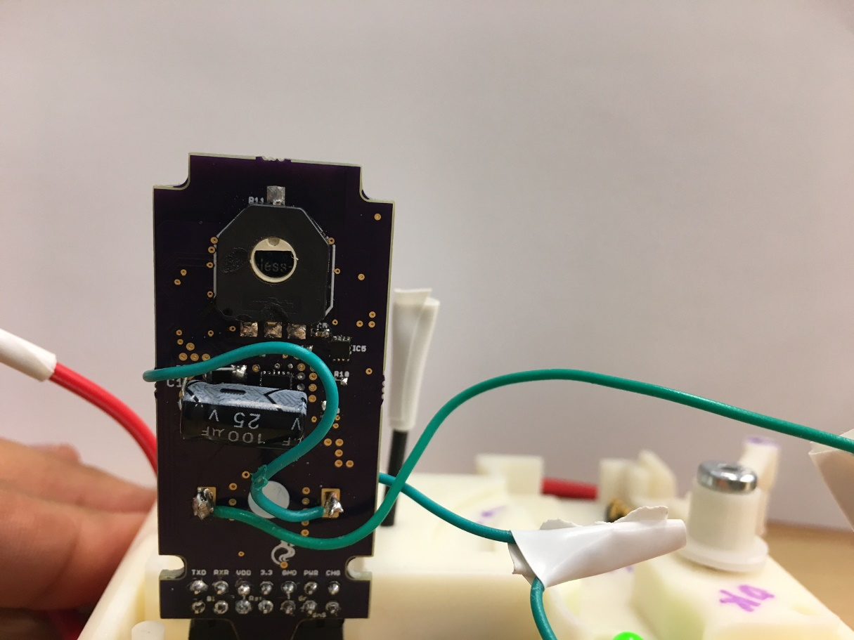Step #2: Ensure Potentiometer Notch Faces Up

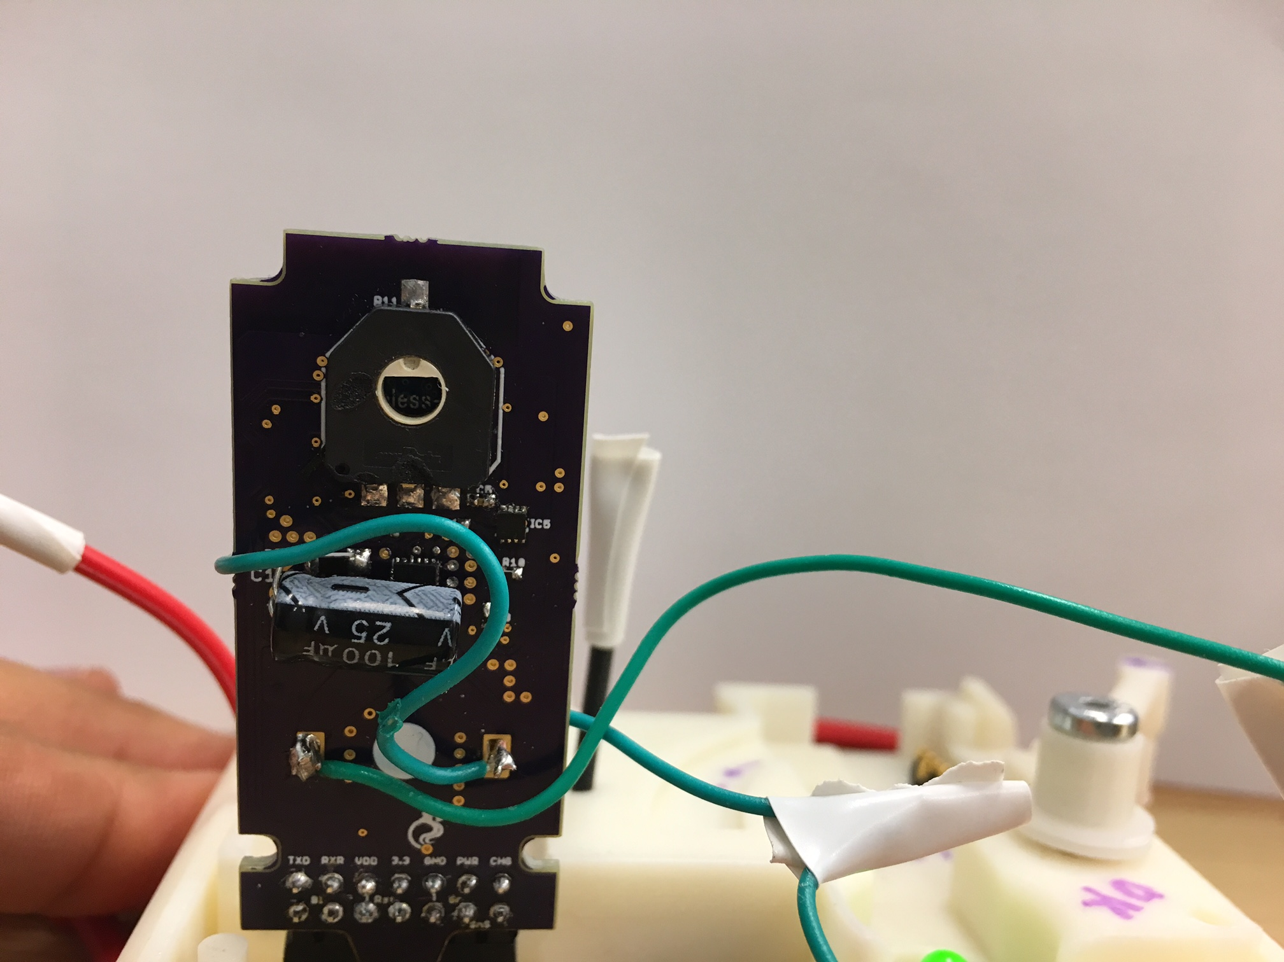

Step 3: Push Button On Programmer for 5sec => Download Begins

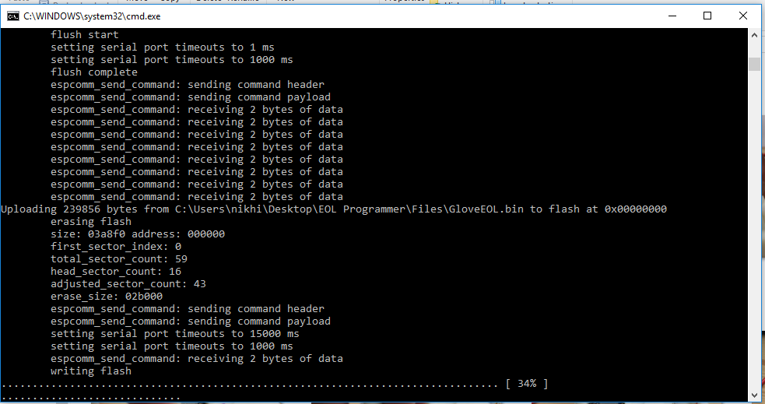

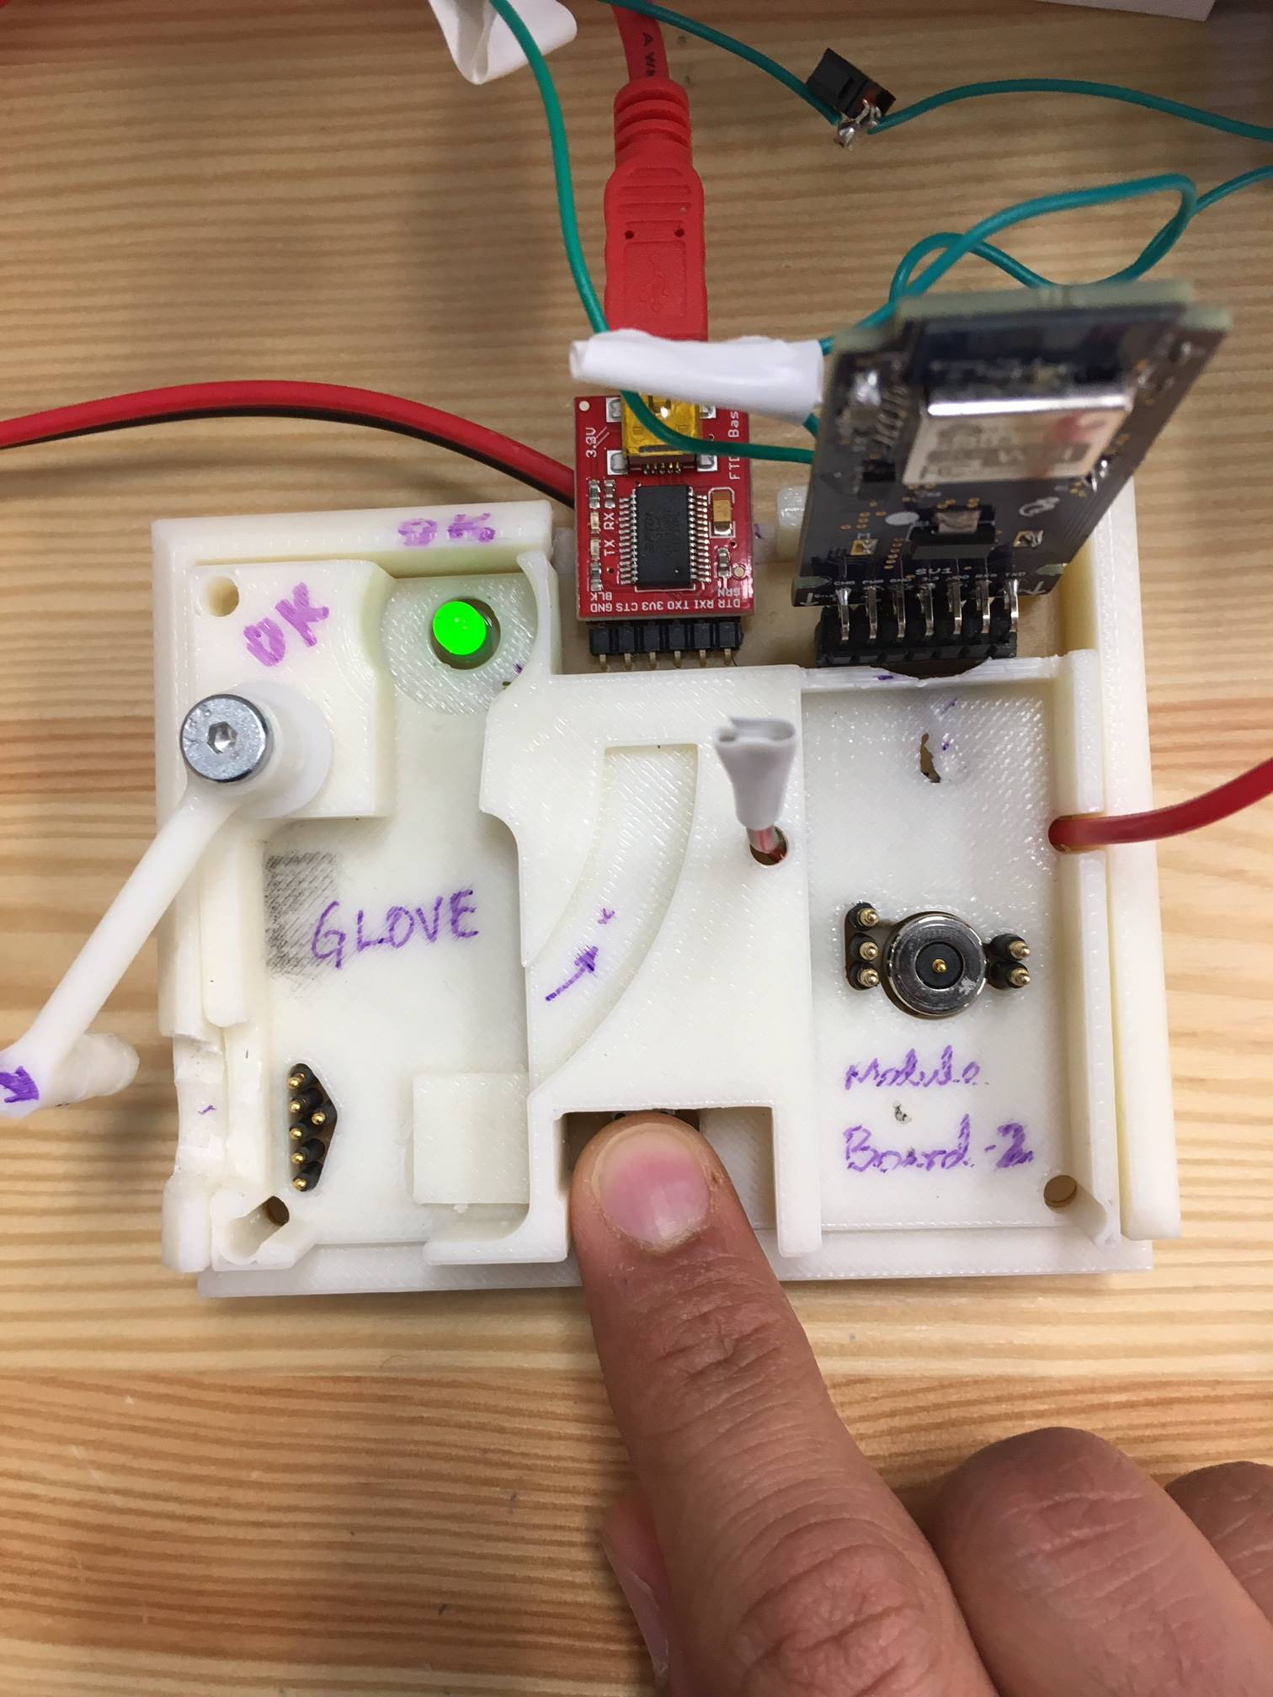

Press Button for **5** sec

**Light Blink during Download**

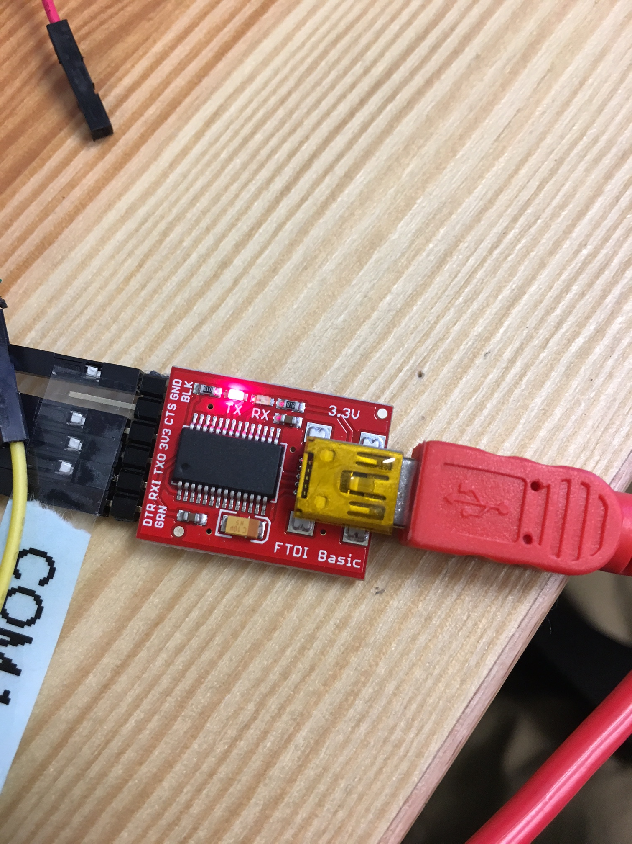

Download Begins. Status shown on Screen

Step 4: After Download, EOL Runs and Turns Programmer and Controller light

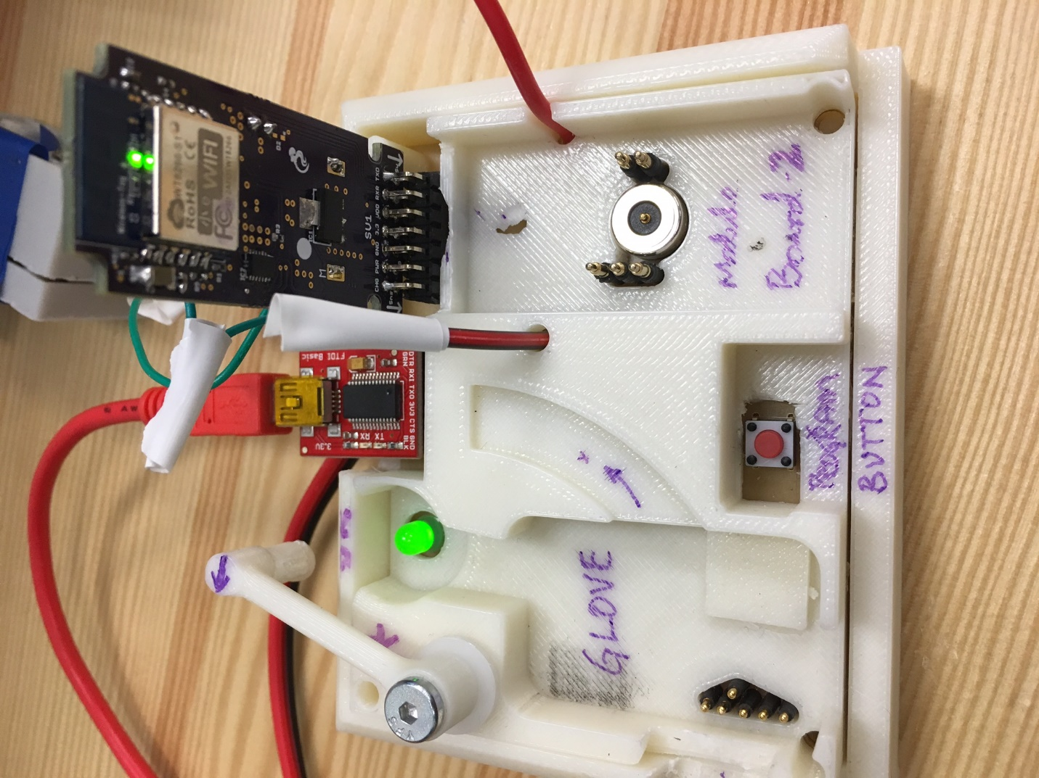

IF BOTH LIGHTS TURN GREEN=> **SUCCESS**

Repeat Steps 1 to 4

For any other questions call **+1-765-476-3370** or email **nikhil@zeroui.com**